
Alexandra Cote’s Growth Portfolio
Hi! I’m Alexandra, a SaaS growth marketer and content strategist with 50+ other side hobbies. My main interest remains getting content to rank and helping B2B companies grow their audience and lead generation efforts. I provide a people-first approach to marketing for companies in the SaaS industry.

What I can do for you:

As a content and growth marketing strategist, I have experience working for large-scale companies including Paymo, Wynter, Digitail, Krisp, DesignFiles, Enzuzo, Deepcrawl, ClickFlow, TINYpulse by Limeade, Zenhub, Talentsoft (acquired by Cegid), Panther, FreshBooks, Karat, CloudMatos, Yobs, Zeplin, MorphL (acquired by Algolia), Stoke, WiseTime, Interact, Taskade, MailPoet, HolaBrief, Similarweb, Sociality.io, Fixel, Zest, Maze, RE(SOURCE), and more.

Next are a few things I can help with but you can also access the complete services proposal:

- Content Strategy & Audits
- Content Writing & Editing
- Content Operations
- SEO and CRO
- Social Media Strategy & Posts
- Content Repurposing & Outreach
- Brand Messaging & Positioning
- SaaS Landing Pages and Product Blurbs
- Product Marketing
- Email Marketing [more email samples]
- Customer Research
- Account-based marketing pilots for startups

Reader testimonials:

“This was an amazingly well-done article, thank you!”

“This is perhaps one of the best Project management articles ever written. Brilliantly researched, explained, and mindful. Thank you for the information.”

“Thanks for sharing the valuable article. Got the exact information I was searching for. Looking forward to more updates.”

“I have to tell you this is the only article I didn’t skim and scan. Because I felt there are some quite unique points here that I haven’t read anywhere else.”

“You’re a writing wizard!”

“I would like to commend you on your very thorough and informative article. You went above and beyond in the information you provided.”

*Client testimonials available on my LinkedIn profile

Here’s a good look at some of the content I wrote:

- Articles on my own blog
Here are three of my top-performing posts and the value they’ve brought:
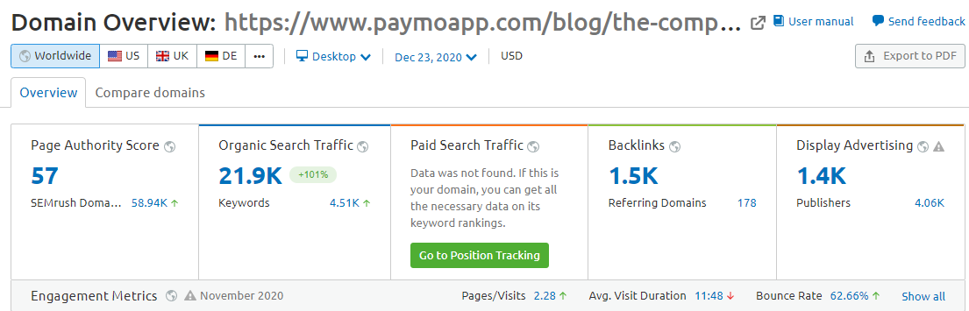
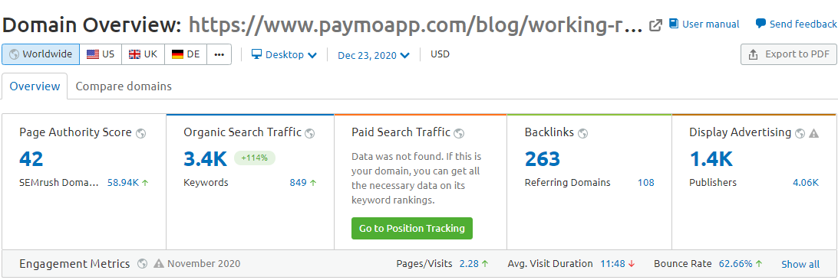
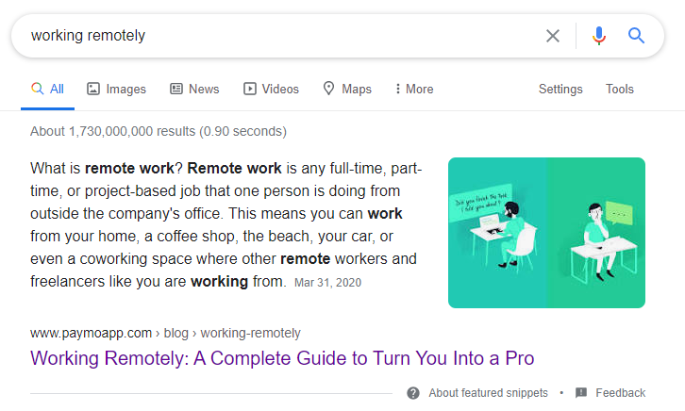
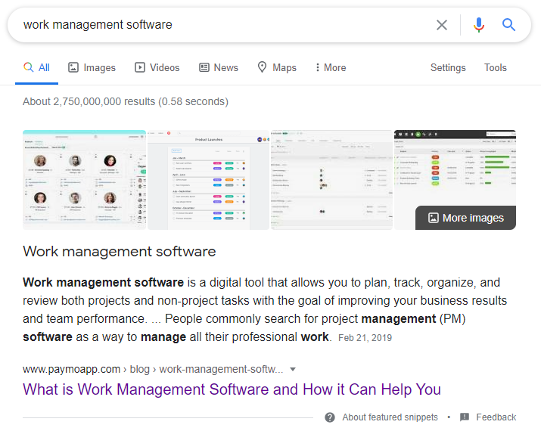

Remote work
- Pros and Cons of Remote Work: Will Your Employees Adapt? - Entrepreneur
- Working Remotely: A Complete Guide to Turn You Into a Pro - Paymo
- Remote Teams Guide: How to Manage Your Remote Software Development Team - freeCodeCamp
- A remote team manager's guide to cultural diversity in the workplace - Panther
- Is a Remote Product Management Career Sustainable? - freeCodeCamp
- Best Remote Work Advice According to Your Personality Type - Virtual Vocations
- The Re-Birth Of Remote Team Productivity - Taskade

HR and team culture
- WHAT YOUR EMPLOYEES ARE STRUGGLING WITH NOW (AND HOW YOU CAN HELP) - Urban Sports Club
- Reduce Recruitment Costs Using These 6 Methods - Panther
- 4 Ways To Use HR Data To Improve Employee Experience - Talentsoft
- The Role of the Manager in 2021: How to Equip Your Managers to Lead Change - Talentsoft
- Why You’re Not Happy With Your Career - Thrive Global
- Advance Your Career Through Professional Growth - Paymo
- 12 Tips for Onboarding Remote Employees - Solvusoft
- Why People Take Job Burnout So Lightly - StartUp Mindset
- How to Run Effective Remote One-on-One Meetings | 9 Tips for Success - Krisp
- E-Guide: A Step-by-Step Guide to Setting up an Employee Appreciation Plan - USC
- 7 Remote Recruiting Tips to Help You Reach the Right Talent - Panther
- 10 Best Online Employee Scheduling Software - People Managing People
- How to Create a Profit and Loss Statement - Hourly

PM and productivity
- How To Be Productive Working From Home In 7 Steps - Krisp
- Becoming a Project Manager – A Complete Guide - Paymo
- Agile Release Planning in Software Development - Step-by-Step Guide - ZenHub
- You Don't Know What You're Spending Your Time On Unless You Start Tracking It - Hacker Noon
- Productivity at Work: The Only Steps You Need to Go Through - Solvusoft
- 9 Tips To Becoming A Project Manager - Glassdoor
- How time tracking can solve your freelancing productivity and budget problems - 99desgins
- Unlocking The Secrets To Good Time Tracking - Twine
- How to Manage a Web Design Project with Paymo - Envato Tuts+
- Top 44 Project Management Tools Tested and Reviewed - Paymo
- How Project Management Software Can Help You Manage Your NGO Project - AsianNGO
- Four project management stages all projects go through - APM
- Manage Your Time, Projects, And Accounting With Paymo - DPM

Marketing
- The 4 Ps Of Marketing + 4 New Ps - KlientBoost
- 15 Marketers Share How Quizzes Have Helped Their Content Marketing Efforts - SurveyAnyplace
- Nonprofit video content strategies: 4 creative ways to promote your cause - Wibbitz
- Complete List Building Guide (plus 4 Email Template Categories) - Interact
- The Growth Hacking Guide for Every Marketer - Swaymetrics
- 27 Pro Marketers Share How They Handle Marketing Automation Challenges - MailMunch
- 10 Great Business Email Examples to Use as Inspiration - MailPoet
- Content curation: A marketer’s guide to creating engaging new articles - Zest
- SEO vs. SEM: What are the differences and where they meet - Mangools
- Content Curation on Social Demands More Than a Shared Link - CMI
- 20 Ways to Promote & Distribute Your Blog Post - Woorise
- The Rise of the Chief Empathy Marketing Officer - Zest
- 16 On-Page SEO Factors You Must Update On Your Blog At All Times - Business 2 Community
- 3 Scalable Content Promotion Strategies to Blast Your Funnel - Single Grain

AI
- Embracing Artificial Intelligence In Marketing – Differences, Similarities and Strategies - MorphL
- What Is the Difference Between Predictive and Prescriptive Analytics – Ecommerce Applications - MorphL
- Going from A/B Testing to Artificial Intelligence. Differences, similarities and strategies. - MorphL
- The Marketing Technologist Role And AI - MorphL
- Top 8 Artificial Intelligence Apps for Your Shopify Store - MorphL

Other business topics
- The ultimate roadmap to scaling a design business and staying competitive - HolaBrief + ebook
- Reporting usability testing results and findings - Maze
- How to acquire subject matter expertise in a product - Product Marketing Alliance
- How to Find the Best Niche for Affiliate Marketing in 2021 - Similarweb
- Planning for Profit: How to Build Profitability Models - FreshBooks

Ecommerce
- The AI Of Personalized Ecommerce Product Recommendations - MorphL
- Top 7 Most Powerful Personalization Apps for Shopify - Understanding Ecommerce
What types of content I write:

- Long-form guides
- Video scripts
- Tool and expert round-ups
- Case studies and interviews
- Reviews and comparisons
- Newsletter ideation and content
- Social media posts [LinkedIn, Twitter, Instagram, Reddit, Facebook]
- Tests for evaluating marketing candidates
- Original research and studies
- Side-project content
- Ebooks and checklists

My topics of expertise are:

- Productivity, leadership, and project management
- SaaS
- All things design!
- Marketing, social media, and writing
- Careers, HR, recruitment, and workplace management
- Task and time organization/tracking
- Work issues and mental health at work
- Team management and collaboration
- Freelancing and small businesses
- Client management and collaboration
- E-commerce and marketing AI

Connect with me at cotealexandra11@gmail.com to talk about how I can help you with your upcoming growth projects.

